Course Name | ITD 2343 – Object Oriented Programming with C#
Instructor | Mark L. Pranger
Student Name | Eric Christensen
Due date | Sept 16, 2025
Grade | <grade earned here>
Grading Comments | <instructor comments here>

Week 3 – Programming Lab

In the exercise, the coding must be fixed so the 5 buttons show and work correctly when run. The project MUST compile and run when submitted.

The names that should be used for the buttons and the label are in the coded click methods for the buttons. The code in the initial components will be code that needs to be changed. The btnRed is coded correctly and can be used as a guide to fixing the rest.

Once all the coding is set back correctly, some minor changes can be made to the form itself.

The Color buttons should have the same top as the label.
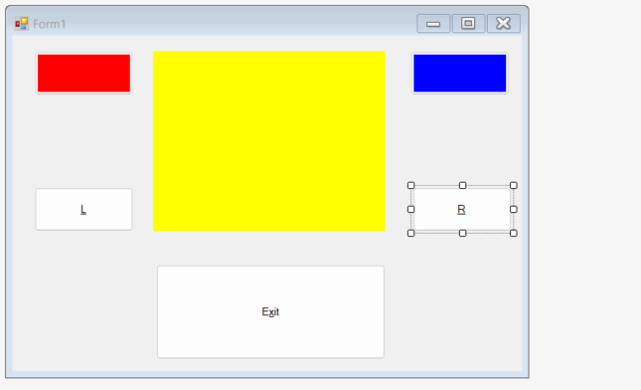

The Left and Right buttons should have the same bottom as the label.

The Exit button should be as wide as the label and be underneath it.
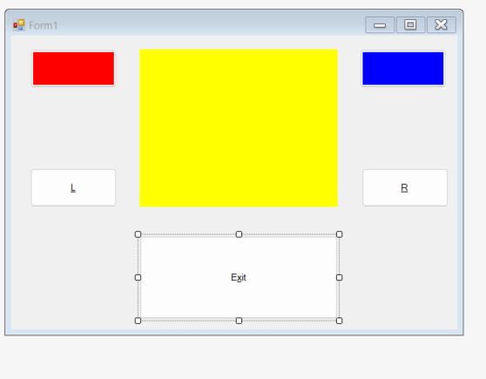

The text in the label should be large and centered in the middle with times new roman font and color of the text black.
Done

The face of the color buttons should be visible as colors only BUT have a hot key for each appropriate to the color. (This means it will have to have some text on it but the user should not see the text)
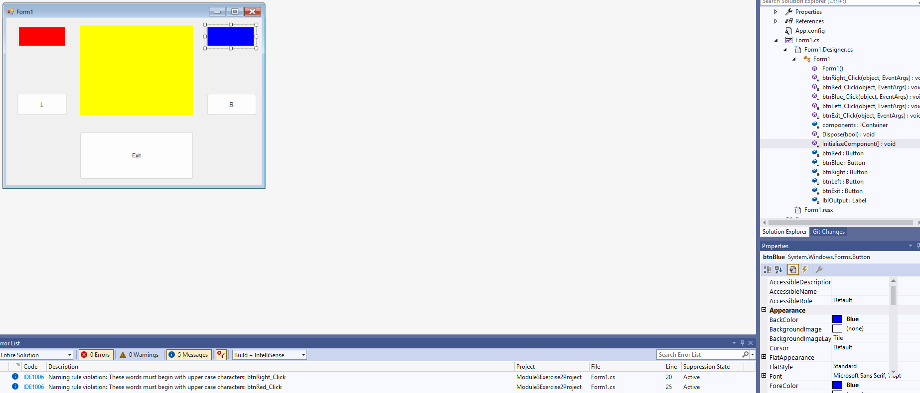

The left and right buttons' faces should only have the letters L and R respectively and hot keys tied to them.
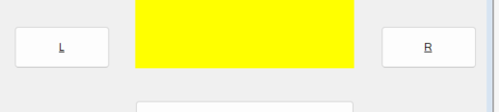
-Both hot keyed as shown by the letters being Underlined.

The escape key should be set up to fire off the exit button.

Tab order should be Red, Blue, L, R, Exit buttons.
Tab index is set in the code and appears correct

ALL coding changes made need to be marked with comments to bring attention to the "changes" that were made to fix the code.

